SUMMER TRAINING PROJECT REPORT

ON

“IMPLEMENT AND COMPARE SORTING ALGORITHMS(QUICK,MERGE,HEAP)”



SUBMITTED BY: Esha Dey

REGISTRATION NO.: 12222770

In partial fulfillment for the requirements of the award of the

degree of

“**Bachelor of Technology in Computer Science and Engineering-**

**Cloud Computing**”

School of Computer Science and Engineering

Lovely Professional University

Phagwara, Punjab.

**Undertaking from the student**

I, Esha Dey, Registration number 12222770, hereby declare that the information provided by me in the above format are complete and true to the best of my knowledge , belief and information. I, hereby undertake the present recordings of the sessions of verification immediately upon demand by the concerned authorities of the university. In case of any of the above-mentioned information is found wrong or in-correct then disciplinary action can be initiated against me by the university.

Name of the student: Esha Dey

Date: 20th July 2024

**CERTIFICATE**

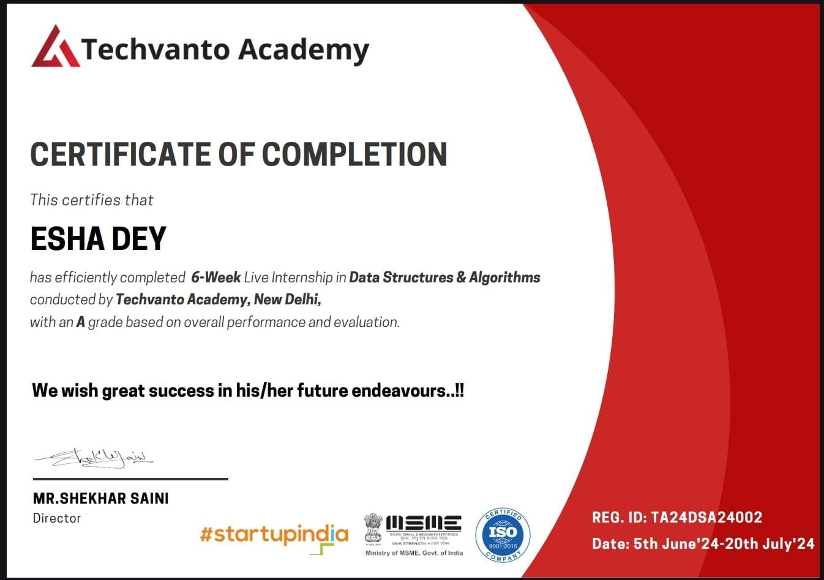

**INTRODUCTION**

In accordance with the curriculum for the term **324251**, I am required to participate in a course named "SEMINAR ON SUMMER TRAINING". Based on my grades in a few courses in the previous semesters, I was allocated to the niche category of summer training. And hence from the list of niche category courses, I had chose a course on Data Structures and Algorithms by Techvanto Academy.

Summer Training Courses: <https://sites.google.com/lpu.co.in/summertraining2026/home?authuser=0>

<https://docs.google.com/spreadsheets/d/1dv9BnHSsD0EJPq5JxCXPZ3CgFTlMscVsl95PzaBKfm0/edit?gid=0#gid=0>

Techvanto Academy:

* Syllabus: <https://drive.google.com/file/d/1AEaXyMcqxWno9QgWf9e-LWfsS-uRMv4R/view>
* Trainer Profile: <https://drive.google.com/file/d/1KyvF0x5hyUVZ6R2xM0mQPI2Kwi6I_PkK/view>
* SPOC Mail ID: [info@techvanto.com](https://lpuin-my.sharepoint.com/personal/esha_12222770_lpu_in/Documents/info@techvanto.com)

**ABOUT TECHVANTO ACADEMY**

I recently completed the Data Structures and Algorithms course at Techvanto Academy, and it has been a transformative experience for my career. The course offered a unique blend of in-depth theoretical knowledge and practical application, which has significantly enhanced my technical skills.

Earning an ISO Certificate of completion, accredited by Techvanto Academy in association with IITs, has been a great boost to my professional profile. This certification is recognized and respected, adding immense value to my resume.

Learning from “industry experts” was another highlight. The instructors brought in their rich experience from the tech industry, making complex concepts easy to understand and apply. The course was designed to be 90% practical, which meant I was constantly applying what I learned in a real-world context, something that most courses don't offer.

The live classes were interactive and engaging, allowing me to ask questions in real time and receive immediate feedback. Moreover, the course provided me with access to placement interviews, which led to several exciting job opportunities.

One of the unexpected but valuable aspects of the course was the networking opportunities. I connected with like-minded peers and industry professionals, which has already opened up new avenues for collaboration and career growth.

Overall, this course has played a crucial role in my professional growth, equipping me with the skills, certification, and connections needed to thrive in the tech industry. I highly recommend it to anyone looking to advance their career in data structures and algorithms.

**OBJECTIVE TO BE ACHIEVED**

The **Data Structures and Algorithms** course by Techvanto Academy is designed with clear, focused objectives to ensure that participants gain both theoretical knowledge and practical expertise. The key objectives of this course include:

1. **Mastery of Core Concepts**: Equip students with a deep understanding of data structures and algorithms, enabling them to solve complex computational problems efficiently.

2. **Practical Application**: Provide hands-on experience through a 90% practical internship, allowing students to apply learned concepts in real-world scenarios.

3. **Industry-Ready Skills**: Prepare students for the tech industry by teaching them industry-relevant technologies and practices, guided by seasoned professionals.

4. **Certification and Recognition**: Offer an ISO Certificate of completion in association with IITs, enhancing the professional credentials of participants.

5. **Career Advancement**: Facilitate career growth by offering internship opportunities, placement interviews, and potential full-time job offers post-training.

6. **Professional Networking**: Create opportunities for students to network with peers, instructors, and industry professionals, fostering connections that can lead to future collaborations and job opportunities.

7. **Comprehensive Learning Experience**: Deliver a balanced learning experience through live classes that encourage interaction, engagement, and immediate feedback, ensuring that every participant is well-prepared for

**VARIOUS STEPS TAKEN TO ACHIEVE THE OBJECTIVES**

**WEEK 1**

INTRODUCTION TO DATA STRUCTURES AND ARRAYS

• Course Overview

• Introduction to Data Structures

• Arrays: Definition, Operations, Time Complexity Analysis

• Implementing Arrays in Programming Languages

• Project: Implement Basic Array Operations

**WEEK 2**

**LINKED LISTS AND STACKS**

**•** Singly Linked Lists: Definition, Operations, Implementation

• Doubly Linked Lists: Definition, Operations, Implementation

• Stack Data Structure: Definition, Operations, Applications

• Implementing Stacks in Programming Languages

• Project: Implement Linked List and Stack Operations

**WEEK 3**

**QUEUES AND TREES**

• Queue Data Structure: Definition, Operations, Applications

• Implementing Queues in Programming Languages

• Binary Trees: Definition, Operations, Traversal Techniques

• Binary Search Trees (BST): Definition, Operations, Properties

• Implementing Trees in Programming Languages

• Project: Implement Queue and Tree Operations

**WEEK 4**

**SORTING AND SEARCHING** **ALGORITHMS**

• Sorting Algorithms: Bubble Sort, Selection Sort, Insertion Sort

• Merge Sort and Quick Sort: Concepts, Implementation, Analysis

• Searching Algorithms: Linear Search, Binary Search

• Project: Implement Sorting and Searching Algorithms

**WEEK 5**

**DYNAMIC PROGRAMMING AND HASHING**

• Dynamic Programming: Concepts, Memoization, Tabulation

• Dynamic Programming Problems and Solutions

• Hashing: Concepts, Hash Functions, Collision Handling

• Hash Tables: Operations, Implementations

• Project: Solve Dynamic Programming Problems and Implement Hash Table

**WEEK 6**

**GRAPH ALGORITHMS AND COMPETITIVE PROGRAMMING**

• Graph Representation: Adjacency Matrix, Adjacency List Graph Traversal: Breadth-First Search (BFS), Depth-First Search (DFS)

• Shortest Path Algorithms: Dijkstra's Algorithm, Bellman-Ford Algorithm Minimum Spanning Tree Algorithms: Prim's Algorithm, Kruskal's Algorithm

• Competitive Programming Challenges and Contests Capstone Project: Solve Complex Algorithmic Problems and Participate in Coding Contests

• Project Presentation and Demonstration • Doubt Clearing Sessions and Feedback

**PROJECT TOPIC:** IMPLEMENT AND COMPARE SORTING ALGORITHMS(QUICK,MERGE,HEAP)

One of the projects assigned during the **Data Structures and Algorithms** course at Techvanto Academy was focused on **"Implement and Compare Sorting Algorithms: Quick, Merge, Heap."** This project was a crucial part of the curriculum, designed to deepen our understanding of sorting algorithms, their implementation, and their efficiency.

* Project Overview:

The objective of the project was to implement three key sorting algorithms—Quick Sort, Merge Sort, and Heap Sort—from scratch using a programming language of our choice. After implementing each algorithm, we were required to compare their performance based on several factors, including time complexity, space complexity, and execution time on different data sets.

* Implementation:

- **Quick Sort**: We implemented the Quick Sort algorithm, which uses a divide-and-conquer approach. The project required careful attention to choosing an effective pivot and handling cases of worst-case performance, particularly on sorted or nearly sorted data.

- **Merge Sort**: The Merge Sort algorithm was implemented next, which also uses a divide-and-conquer strategy. The focus here was on understanding how the recursive splitting of arrays and the merging process contributes to its stable and predictable performance.

- **Heap Sort**: Finally, we implemented Heap Sort, which is based on binary heap data structures. This required understanding heap operations like insertion and deletion, and how they affect the sorting process.

* Comparison and Analysis:

After successfully implementing the algorithms, we conducted a detailed analysis and comparison. We tested each algorithm on different types of data sets—random, sorted, and reverse-sorted arrays. The key metrics for comparison included:

- **Time Complexity**: We analyzed the theoretical and actual runtime for each algorithm.

- **Space Complexity**: We compared the memory usage, especially considering Merge Sort's additional space requirements.

- **Execution Time**: We measured the actual execution time for sorting large data sets, using built-in timers to record and compare the efficiency of each algorithm.

* Learning Outcomes:

This project significantly enhanced our understanding of how different sorting algorithms operate under various conditions. We learned not only the technical implementation details but also the importance of choosing the right algorithm for the right problem. The hands-on experience with coding and analyzing these algorithms solidified our grasp of their strengths, weaknesses, and real-world applications.

* Conclusion to the project: The project was an invaluable part of the course, providing us with practical skills and deeper insights into algorithmic efficiency. By implementing and comparing Quick, Merge, and Heap Sort, we gained a comprehensive understanding of sorting algorithms that will be crucial in future technical challenges and job roles.

**EFFECTIVENESS**

I have found that going to Techvanto Academy's Data Structures and Algorithms course has greatly improved both my technical abilities and employment opportunities. With the help of the course's skilled instruction and emphasis on practical learning, I was able to grasp difficult concepts and apply them to practical circumstances. The practical internship furnished priceless experience, while the in-person classes presented lively and participatory educational opportunities. My professional profile was further strengthened by the ISO-certified completion and networking possibilities, which resulted in real career benefits like job offers and industry recognition. All in all, the course was a life-changing event that greatly increased my confidence and preparedness for the tech sector.

**CHALLENGES**

A few difficulties might come up in Techvanto Academy's Data Structures and Algorithms course, but they can be successfully handled with the appropriate strategy:

* Conceptual Complexity: Initially, understanding some data structures and algorithms may be challenging. It's critical to routinely review course materials, ask instructors for clarification, and engage in consistent coding practice in order to address this.
* Time management: It can be difficult to juggle the burden from the course with other obligations. Maintaining a consistent pace can be facilitated by planning a systematic study routine and dividing work into small, achievable chunks.
* Practical Application: It might be intimidating to apply theoretical knowledge to practical issues. Active participation in the practical internship and peer collaboration can offer the encouragement and self-assurance required for success.
* Keeping Up with Live Classes: It can be difficult to make up lost time if you miss a live lesson. Use the sessions that have been recorded, and ask your teachers or fellow students for clarifications or summaries.

These difficulties can be solved and a successful and fulfilling course experience can result from remaining proactive, asking for assistance when necessary, and practicing often.

**LEARNING OUTCOMES**

Several important learning objectives are met in Techvanto Academy's Data Structures and Algorithms course:

1. Expertise in Data Structures: Acquire a firm grasp on a variety of data structures, such as trees, graphs, linked lists, and arrays, and discover efficient ways to use them in code.
2. Algorithmic Thinking: Improve your problem-solving abilities and enable effective coding solutions by learning to develop, analyse, and optimise algorithms.
3. Practical Experience: To bridge the gap between theory and application, obtain practical experience through real-world projects and a practical internship.
4. Technical Self-Assurance: Gain self-assurance in managing intricate computational issues, preparing you for technical positions in the industry.
5. Certification and Career Advancement: In collaboration with IITs, obtain an ISO-certified completion certificate to strengthen your CV and lead to new professional prospects.
6. Networking and Professional Development: Make connections with peers and industry experts to broaden your professional network, which may lead to joint ventures and employment opportunities.

These results give you the information and abilities you need to succeed in the tech sector and grow in your profession.

**CONCLUSION**

In summary, Techvanto Academy's **Data Structures and Algorithms** course provides a thorough and hands-on learning experience that successfully closes the knowledge gap between theory and actual application. Along with providing participants with technically sound skills that are in high demand, the course offers chances for professional growth such as internships, job placements, and certifications. Proactive participation and assistance effectively manage the problems that arise during the course, enabling participants to derive maximum benefits from the program. All things considered, the course fulfils its objective of preparing students for lucrative professions in the technology sector, making it an extremely worthwhile investment in one's career advancement.